**Bash Scripting**

**Shell Related Commands:**echo $0 – To know current shell.

cat /etc/shells – List of available shells.

cat /etc/passwd – To know which shell user is assigned with.

To change the shell just enter shell name sh / csh / tsch / ksh as required.

#!/bin/bash

#! – shebang

/bin/bash – shell.

**Script format:**

Steps which will help other users to understand our script easily.

1.Define Shell (#!/bin/bash)

2.Commenst (# comments)

3.Define Variables (e.g- name=mubeen)

4.Commands (echo, cp, grep etc,)

5.Statements (if, while, for etc,)

**1)Basic Script Hello world.**mkdir -p /mubeen/scripts  
vi helloworld.bash

chmod 755 helloworld.bash  
./helloworld.bash  
cat helloworld.bash

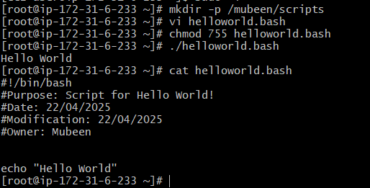

**2)Basic Second Script on commands.**vi commands.bash  
chmod 755 commands.bash

./commands.bash

ls

cat commands.bash

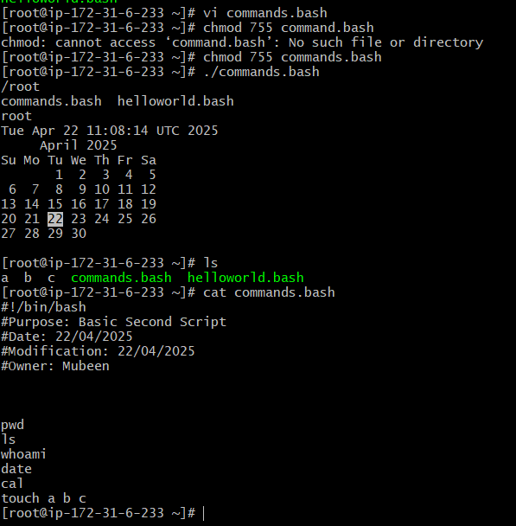

**3)Basic Administration task.**vi admin.bash  
chmod 755 admin.bash  
./admin.bash  
cat admin.bash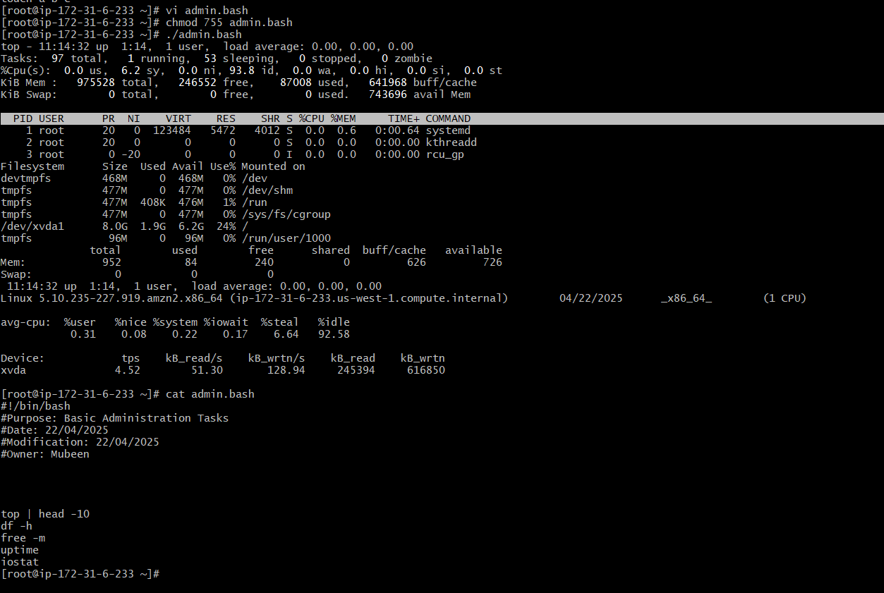

**4)Basic task on variables.**vi variables.bash

chmod 755 variables.bash  
./variables.bash  
cat variables.ba

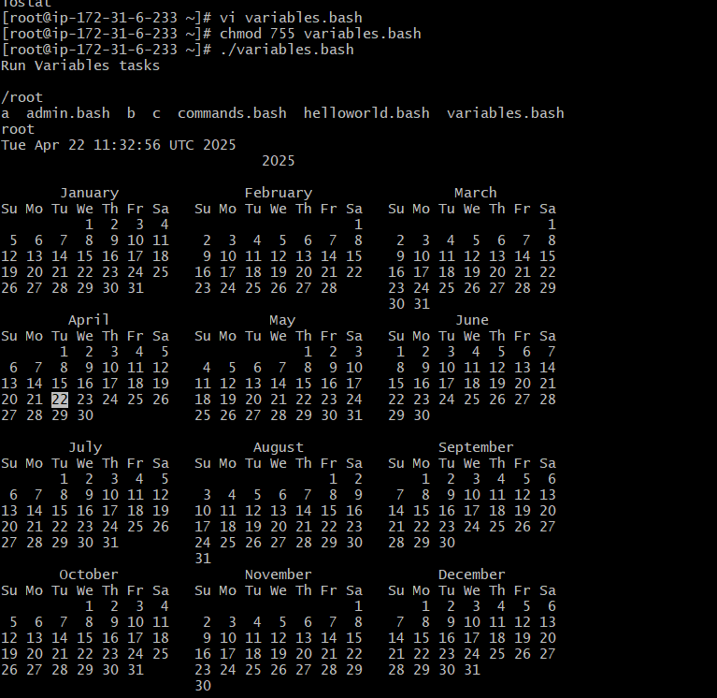

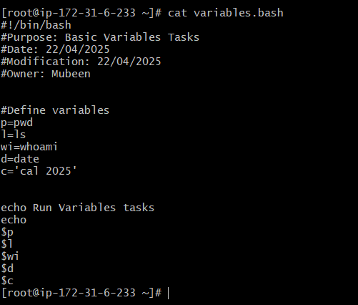

**5)Basic task on Input script.**vi input.bash  
chmod 755 input.bash  
./input.bash  
cat input.bash

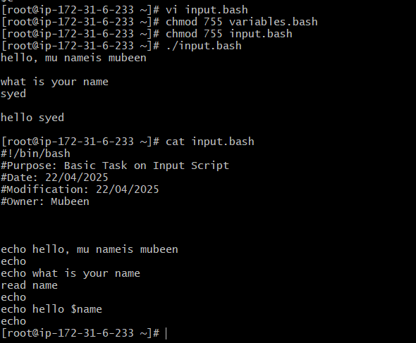

**6)Basic task on Output script.**vi output.bash  
chmod 755 output.bash  
./output.bash  
cat output.bash

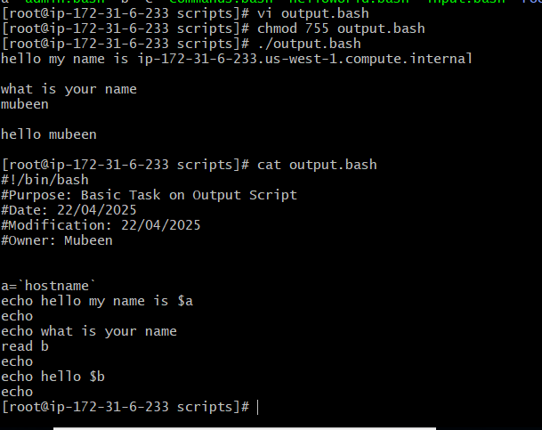  
  
  
Make sure to follow parameters, create specific directory for scripts, Script name should identify the functions added and Script should end with .bash.



**The End**